**7) Objective**

**Define an interface and implement it in any class wherever it is required.**

**Pre-condition**

**Employee, Date and Shape class should be created.**

**Problem Statement**

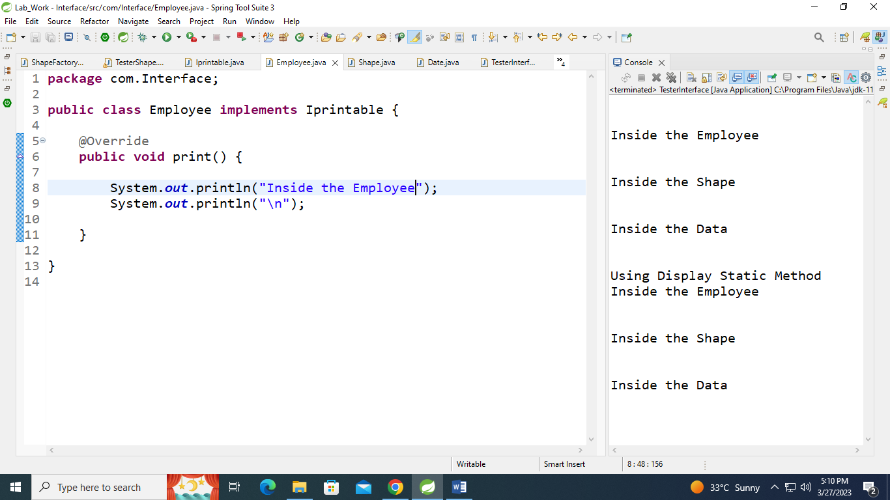

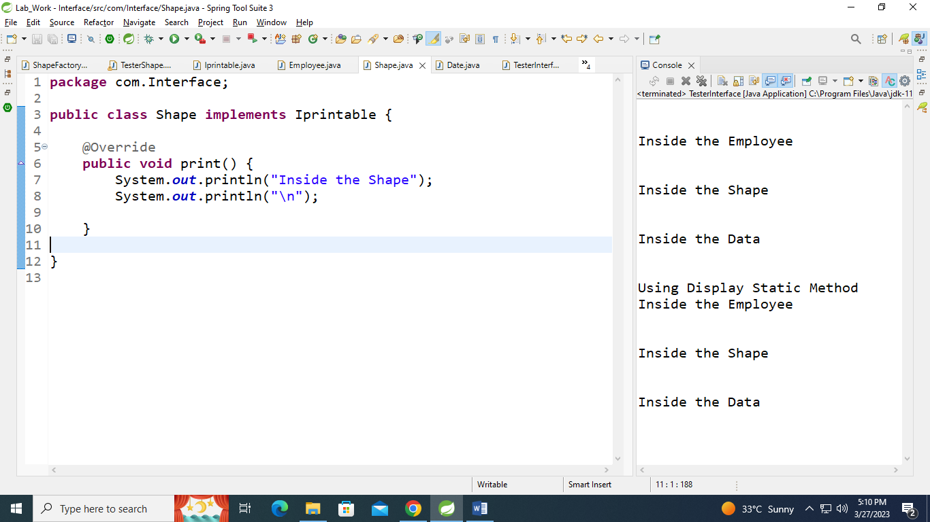

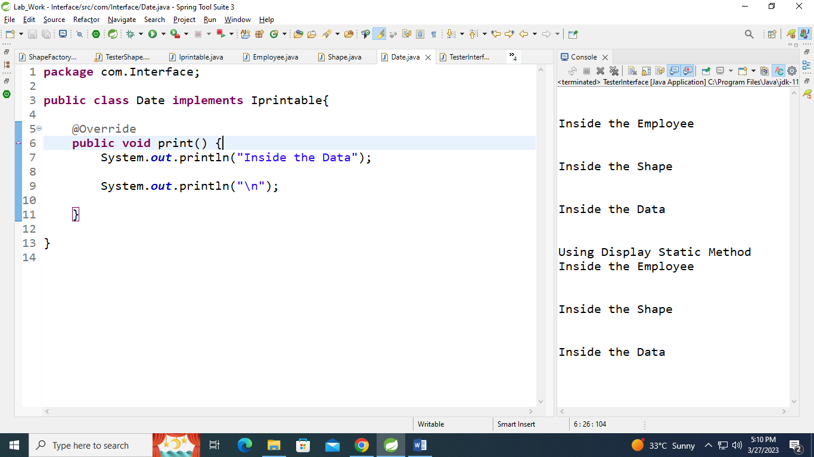

**7.1:Define an interface Printable with a method print(). Implement this**

**interface in Employee, Shape and Date class.**

**package** TesterInterface;

**import** com.Interface.Date;

**import** com.Interface.Employee;

**import** com.Interface.Iprintable;

**import** com.Interface.Shape;

**public** **class** TesterInterface {

**public** **static** **void** disply(Iprintable obj) {

obj.print();

};

**public** **static** **void** main(String[] args) {

System.***out***.println("\n");

Employee emp = **new** Employee();

emp.print();

Shape sh = **new** Shape();

sh.print();

Date dt = **new** Date();

dt.print();

System.***out***.println("Using Display Static Method");

*disply*(emp);

*disply*(sh);

*disply*(dt);

}

}

